Hellenic Accreditation System
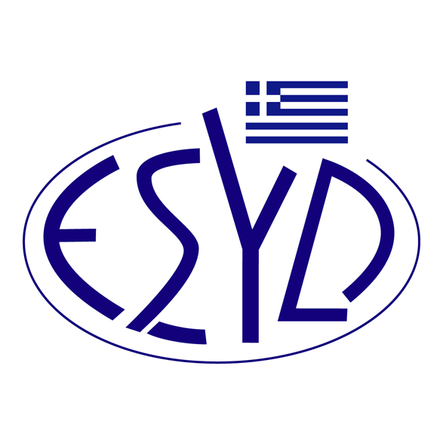

Annex A10/12 to the Certificate No. 236-9

SCOPE of ACCREDITATION
of

TÜV AUSTRIA HELLAS Ltd.

as a Certification Body of Managerial Capability of Organizations Implementing Projects of Public Interest according to ELOT 1429:2008 Standard

Activity | Standard
Managerial capability of organizations implementing projects of public works. | ELOT 1431-1
Managerial capability of organizations implementing public supply contracts and public services contracts. | ELOT 1431-2
Managerial capability of organizations implementing certain actions by own means. | ELOT 1431-3

Address of the Body : 429, Mesogion Avenue, Agia Paraskevi, 15343, Greece
Approved Signatory : Yiannis Kallias, Charalabos Ageloudis, Maria Agapitou

This Scope of Accreditation replaces the previous one dated 02.12.2021.
The Accreditation Certificate Νο.236-9, according to ELOT EN ISO/IEC 17021-1:2015, is valid until 27.12.2029.
This Annex is granted according to ELOT TS 1432:2008.

Athens, 16.12.2024

Konstantinos Kourtalis
Chairman of ESYD

