Hellenic Accreditation System
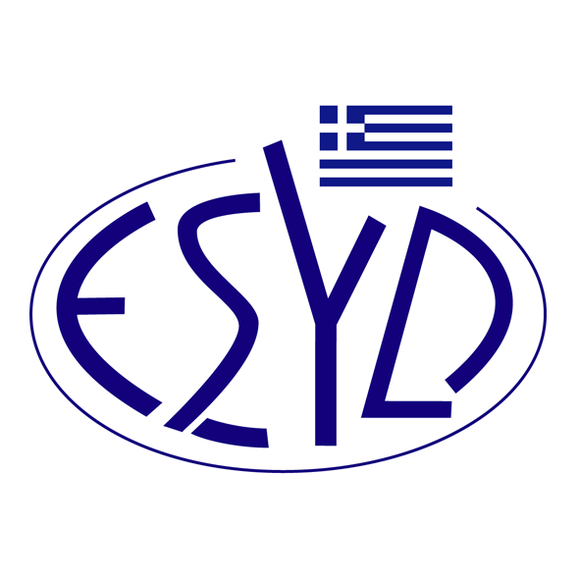
Annex Α22/2 to the Certificate No. 1099-5

SCOPE of ACCREDITATION
of

RIGCERΤ IKE
(RIGCERT)

as a Certification Body of Anti-bribery Management Systems
in accordance with ELOT ISO 37001:2017 Standard

Activity | Standard
Certification of Anti-bribery Management Systems. | ELOT ISO 37001:2017

Address of the Body: 4 Leontos Sofou str., 505, Thessaloniki, Greece
13 Scarlatescu street, sector 1, 011158, Bucharest, Romania
Approved signatories: C. Lupa

This Scope of Accreditation replaces the previous one dated 17.05.2024.
The Accreditation Certificate Νο. 1099-5, according to ELOT EN ISO/IEC 17021-1:2015 is extended until 09.12.2025.

Athens, 30.05.2025

Konstantinou Evangelos Apostolos
CEO of ESYD

