Hellenic Accreditation System
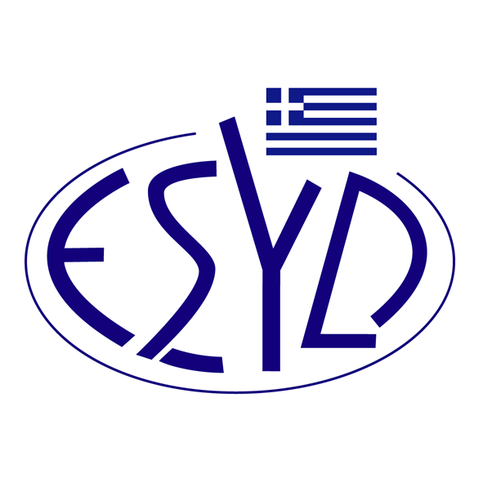
Annex A16/1 to the Certificate No. 546-10

SCOPE OF ACCREDITATION
of

BQC PRIVATE COMPANY
(BQC)

as a Certification Body of Business Continuity Management Systems
in accordance with ΕLΟΤ ΕΝ ΙSΟ 22301:2019

ΕΑ/IAF  Code ⁽¹⁾ | Accredited Activity
28 | Construction of buildings and civil engineering works.
29 | Wholesale and retail trade. Repair of motor vehicles and motorcycles. Personal and household goods.
32 | Financial intermediation. Real estate activities. Renting.
33 | Information technology.
34 | Architectural and engineering activities. Technical consultancy. Research and development.
35 | Other services, except trade, hotels, restaurants, transport, financial intermediation, real estate, information technology, education, health and social work.
37 | Public administration.
39 | Other services, except education, health, and social work.
- ΕA/IAF Code according to IAF ID 1:2020.

Address of the Body: 54, Ag. Dimitriou Avenue, 17 341, Agios Dimitrios, Athens.
Approved signatory: Νiki Panopoulou.

The Accreditation Certificate Νο. 546-10, according to ELOT EN ISO/IEC 17021-1:2015, is valid until 14.05.2025.

Athens, 26.04.2024

Christos Nestoras
CEO of ESYD

