Hellenic Accreditation System
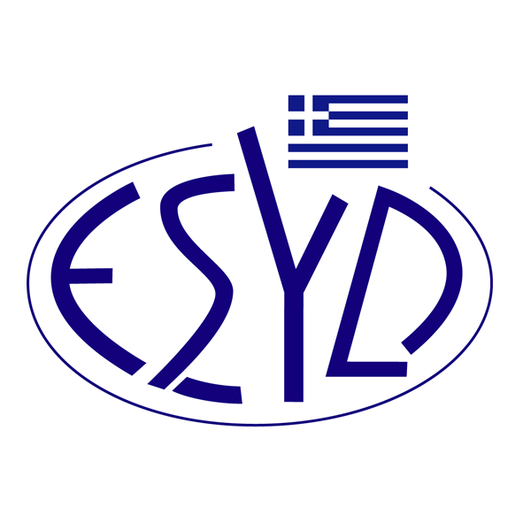

Annex E2/19 to the Certificate EL-V-0006 (No. 207-12)

SCOPE of ACCREDITATION
of

TÜV AUSTRIA HELLAS Ltd.

as an Environmental Verifier
in accordance with the Regulation 1221:2009 (EMAS)

NACE Code⁽¹⁾ | Activity
10 | Manufacture of food products.
11 | Manufacture of beverages.
18.1 | Printing and service activities related to printing.
19.2 | Manufacture of refined petroleum products.
20.1 | Manufacture of basic chemicals, fertilisers and nitrogen compounds, plastics and synthetic rubber in primary forms.
20.3 | Manufacture of paints, varnishes and similar coatings, printing ink and mastics.
21 | Manufacture of basic pharmaceutical products and pharmaceutical preparations.
22.2 | Manufacture of plastic products.
23.7 | Cutting, shaping and finishing of stone.
24.4  (except of 24.46) | Precious metals production. Aluminium production. Lead, zinc and tin production. Copper production. Other non-ferrous metal production.
24.5 | Casting of metals.
25  (except of 25.4) | Manufacture of structural metal products. Manufacture of tanks, reservoirs and containers of metal. Manufacture of steam generators, except central heating hot water boilers. Forging, pressing, stamping and roll-forming of metal. Powder metallurgy. Treatment and coating of metals. Machining. Manufacture of cutlery, tools and general hardware. Manufacture of other fabricated metal products.
31 | Manufacture of furniture.
33 | Repair and installation of machinery and equipment
52 | Warehousing and support activities for transportation.

NACE Code⁽¹⁾ | Activity
38 | Waste collection, treatment and disposal activities. Materials recovery.
39 | Remediation activities and other waste management services.
45.1 | Sale of motor vehicles.
45.2 | Maintenance and repair of motor vehicles.
45.3 | Sale of motor vehicle parts and accessories.
46 | Wholesale trade, except of motor vehicles and motorcycles.
55 | Accommodation.
56 | Food and beverage service activities.
62 | Computer programming, consultancy and related activities.
63.1 | Data processing, hosting and related activities. Web portals.
64 | Financial service activities, except insurance and pension funding
65 | Insurance, reinsurance, and pension funding, except compulsory social security
66 | Activities auxiliary to financial services and insurance activities
70 | Activities of head offices; management consultancy activities
71.1 | Architectural and engineering activities and related technical consultancy.
74 (except of 74.1 & partially in what concerns code 74.9) | Photographic activities. Translation and interpretation activities. On the road customer services.
81.2 | Cleaning activities.
82.19 | Photocopying, document preparation and other specialised office support activities.
82.2 | Activities of call centres.
82.92 | Packaging activities.
84.1 | Administration of the State and the economic and social policy of the community.
84.21 | Foreign affairs.
84.23 | Justice and judicial activities.
84.3 | Compulsory social security activities.
95.1 | Repair of computers and communication equipment.

⁽¹⁾ NACE Code (Statistical Classification of Economic Activities in the European Community) in accordance with the Regulation 1893/2006/EC of the European Parliament and of the Council.

Address of the Body : 429, Mesogion av., 153 43, Aghia Paraskevi, Greece
Approved Signatories : Ioannis Kallias, Iakovina Vardalachou, Charalabos Ageloudis, Maria Agapitou, Konstantinos Mavropoulos

This Scope of Accreditation replaces the previous one dated 23.04.2024.
The Accreditation Certificate EL-V-0006 (No. 207-12), according to ELOT ΕΝ ISO/IEC 17021-1:2015 and Regulation 1221:2009 (EMAS), is valid up to 27.12.2025.

Athens, 26.09.2024

Konstantinos Kourtalis
Chairman of ESYD

