Hellenic Accreditation System

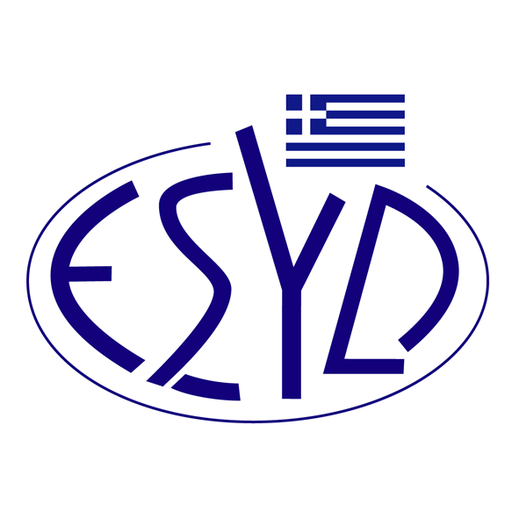

Annex A29/2 to the Certificate No. 236-9

SCOPE OF ACCREDITATION
of

TÜV AUSTRIA HELLAS Ltd.

as a Certification Body of Water Efficiency Management Systems
in accordance with ISO 46001:2019

Activity | Standard
Water Efficiency Management Systems Certification | ISO 46001:2019

Address of the Body : 429, Mesogion Avenue, Agia Paraskevi, 15343, Greece
Approved Signatory : Ioannis Kallias, Charalabos Ageloudis, Rashid Mehr, Maria Agapitou, Ana Vega, Yankı Ünal, Konstantinos Mavropoulos

This Scope of Accreditation replaces the previous one dated 17.01.2024.
The Accreditation Certificate Νο.236-9, according to ELOT EN ISO/IEC 17021-1:2015, is valid until 27.12.2029.

Athens, 16.12.2024

Konstantinos Kourtalis
Chairman of ESYD

