Hellenic Accreditation System
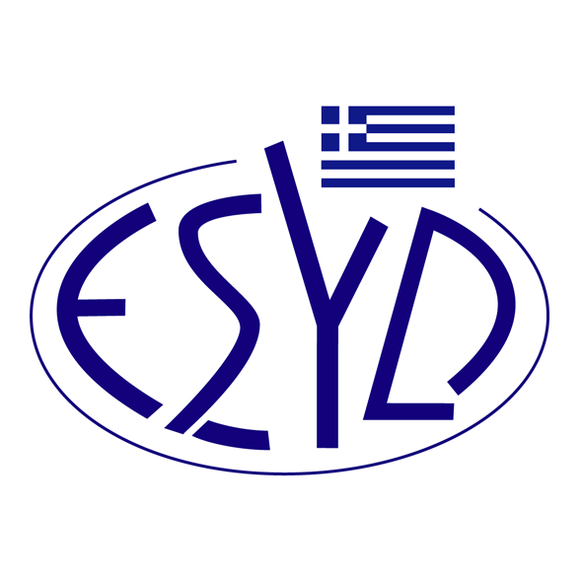
Annex Α25/2 to the Certificate No. 236-9

SCOPE of ACCREDITATION

of
TÜV AUSTRIA HELLAS Ltd.

as a Certification Body of Learning Services outside Formal Education Management Systems in accordance with ELOT ISO 29993:2018 Standard

Activity | Standard
Learning Services outside Formal Education | ELOT ISO 29993:2018

Address of Body head office: 429, Mesogion Avenue, Agia Paraskevi, 153 43, Greece
Approved Signatory: Ioannis Kallias, Charalabos Ageloudis, Rashid Mehr, Maria Agapitou, Ana Vega, Yankı Ünal.

This Scope of Accreditation replaces the previous one dated 31.07.2023.
The Accreditation Certificate Νο.236-9, according to ELOT EN ISO/IEC 17021-1:2015, is valid until 27.12.2029.

Athens, 16.12.2024

Konstantinos Kourtalis
Chairman of ESYD

