Hellenic Accreditation System

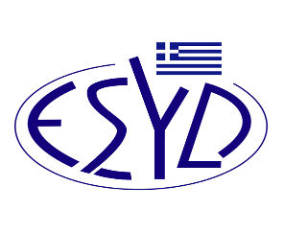

Annex A11/1 to the Certificate No. 546-10

SCOPE of ACCREDITATION
of

BQC PRIVATE COMPANY

(BQC)

as a Management System Certification Body of Companies providing

Communication Services according to ELOT 1435:2009 Standard

Activity | Standard
Advertising agencies. | ELOT 1435
Media Specialists. | ELOT 1435
Public relations. | ELOT 1435
One to one marketing. | ELOT 1435
Branding and design. | ELOT 1435
Address of the Body: 54, Ag. Dimitriou Avenue, 17 341, Agios Dimitrios, Athens.
Approved signatory: Νiki Panopoulou.

The Accreditation Certificate Νο. 546-10, according to ELOT EN ISO/IEC 17021-1:2015, is valid until 14.05.2025.

Athens, 06.03.2023

Christos Nestoras
CEO of ESYD

