Hellenic Accreditation System

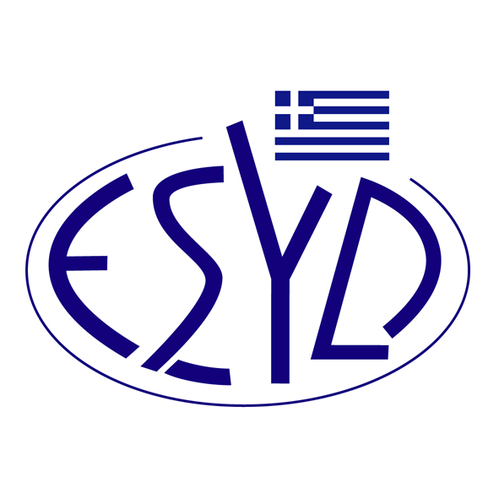

Annex A20/2 to the Certificate No. 110-10

SCOPE OF ACCREDITATION
of

QMSCERT AUDITS-INSPECTIONS-CERTIFICATIONS SA
(Q-CERT SA)

as a Certification Body of Road Traffic Safety Management Systems
in accordance with ΙSΟ 39001:2012 Standard

Accredited Activity ⁽¹⁾
The employee's use of road transport to and from work, or during work, in public transport or private vehicles as passengers or drivers, and as a pedestrian or cyclist.

Transport of goods and passengers within the road transport system, conducted by the organization or outsourced to other organizations.

Activities that generate traffic to or from locations that the organization control or influence, such as supermarkets, schools and places with many visitors

Services for road transport system, such as transport, management, planning, design, construction and maintenance of infrastructure, or activities that are regularly conducted as having an emergency nature as ambulance, tow truck and traffic monitoring and legislative activities.

- According to Annex A 4.1 of ISO 39001:2012

Address of the Body : 28, Vlasiou Gavrielidi street, 546 55 Thessaloniki, Greece
Approved signatories : L. Karanikas, E. Bakirtzi

This Scope of Accreditation replaces the previous one dated 02.06.2023.
The Accreditation Certificate Νο.110-10, according to ELOT EN ISO/IEC 17021-1:2015 is extended until 12.07.2025.

Athens, 18.12.2024

Konstantinos Kourtalis
Chairman of ESYD

