Hellenic Accreditation System

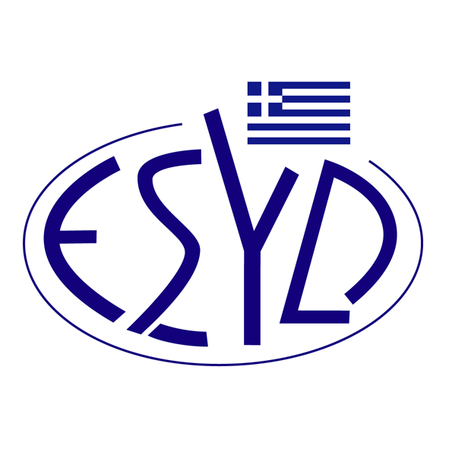

Annex A26/2 to the Certificate No. 236-9

SCOPE OF ACCREDITATION
of

TÜV AUSTRIA HELLAS Ltd.

as a Certification Body of Compliance Management Systems
in accordance with ISO 37301:2021

Activity | Standard
Certification of Compliance Management Systems. | ISO 37301:2021

Address of the Body : 429, Mesogion Avenue, Agia Paraskevi, 15343, Greece
Approved Signatory : Yiannis Kallias, Charalabos Ageloudis, Rashid Mehr, Yanki Unal, Maria Agapitou, Ana Vega

This Scope of Accreditation replaces the previous one dated 05.05.2022.
The Accreditation Certificate Νο.236-9, according to ELOT EN ISO/IEC 17021-1:2015, is valid until 27.12.2029.

Athens, 16.12.2024

Konstantinos Kourtalis
Chairman of ESYD

