Hellenic Accreditation System
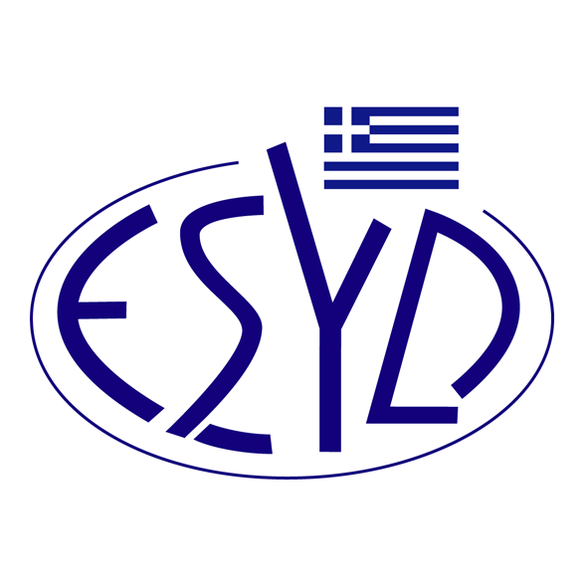
Annex V1/4 to the Certificate No. 1289-3

SCOPE of ACCREDITATION

of

QMSCERT AUDITS-INSPECTIONS-CERTIFICATIONS SA
(Q-CERT SA)

as a Validation and Verification Body
Cluster of Activities | Activity

(in accordance with Annex I of Implementing Regulation (EU) 2018/2067)
6 | - Production of cement clinker  - Production of lime or calcination of dolomite or magnesite  - Manufacture of glass including glass fibre  - Manufacture of ceramic products by firing  - Manufacture of mineral wool insulation material  - Drying or calcination of gypsum or production of plaster boards and other gypsum products
7 | - Production of pulp from timber or other fibrous materials  - Production of paper or cardboard
98 | Other activities pursuant to Article 10a of Directive 2003/87/EC.  Commission Delegated Regulation (EU) 2019/331

Activity | Standard
Verification of reporting of GHG emissions and removals | Specification with guidance at the organization level for quantification and reporting of greenhouse gas emissions and removals according to ELOT EN ISO 14064-1:2019
Address of the Body head offices : 28, Vlasiou Gavrielidi street, 546 55 Thessaloniki, Greece
Approved Signatories : L. Karanikas, E. Bakirtzi

Accreditation is granted according to ELOT EN ISO 14065:2022.

This scope of accreditation replaces the previous one dated 23.01.2023.
The Accreditation Certificate No.1289-3, according to ELOT EN ISO/IEC 17029:2019, is valid until 20.03.2026.

Athens, 12.01.2024

Christos Nestoras
CEO of ESYD

