Hellenic Accreditation System

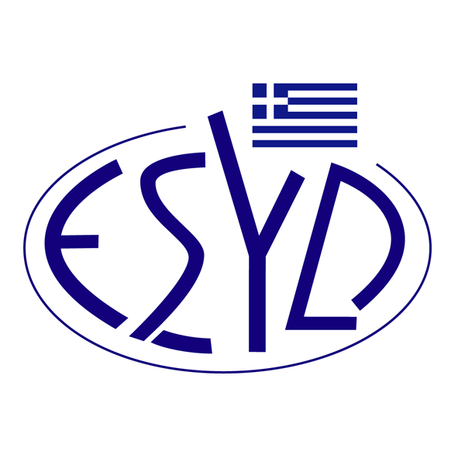

Annex F1/1 to the Certificate No. 1374

SCOPE of ACCREDITATION
of the
Testing Laboratory

OENOANALYSIS-AFRODITI KYRIAKOU

Tested materials/ products | Types of test/ Properties to be measured | Applied Standards/ Techniques to be used
Chemical Tests
Wines | 1. Determination of alcoholic strength by volume | Compendium of international Methods of Analysis -OIV 2016,  OIV-MA-AS312-01B
Wines | 2. Determination of determined acidity by titration | Compendium of international Methods of Analysis-OIV2015  OIV-MA-AS313-01
Wines | 3. Determination of volatile acidity | Compendium of international Methods of Analysis-OIV2015  OIV-MA-AS313-02
Wines | 4. pH determination | Method of Analysis-OIV2011  OIV-MA-AS313-15
Wines | 5. Determination of reducing sugars | Method of Analysis-OIV2009  OIV-MA-AS311-01A

Site of assessment: Laboratory Permanent Premises, 8 Floiountos str., 20500 Nemea
Approved signatories: Afroditi Kyriakou, Panagiotis Thamnidis.

The Accreditation Certificate No. 1374 to ELOT EN ISO/IEC 17025:2017, is valid until 17.12.2028.

Athens, 18.12.2023

Christos Nestoras
CEO of ESYD

