Hellenic Accreditation System
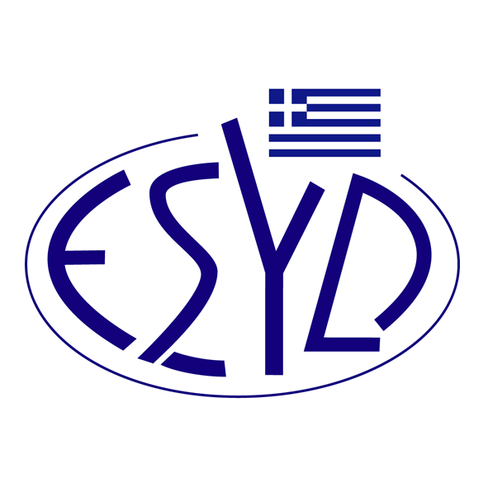

Annex Α22/6 to the Certificate No. 546-10

SCOPE OF ACCREDITATION
of

BQC PRIVATE COMPANY
(BQC)

as a Certification Body of Anti-bribery Management Systems
in accordance with ELOT ISO 37001:2017 Standard

Activity | Standard
Certification of Anti-bribery Management Systems. | ELOT ISO 37001:2017

Address of the Body: 54, Ag. Dimitriou Avenue, 17 341, Agios Dimitrios, Athens.
Approved signatory: Νiki Panopoulou.

This Scope of Accreditation replaces the previous one dated 08.07.2022.
The Accreditation Certificate Νο. 546-10, according to ELOT EN ISO/IEC 17021-1:2015, is valid until 14.05.2025.

Athens, 22.08.2022

Christos Nestoras
CEO of ESYD

