Hellenic Accreditation System
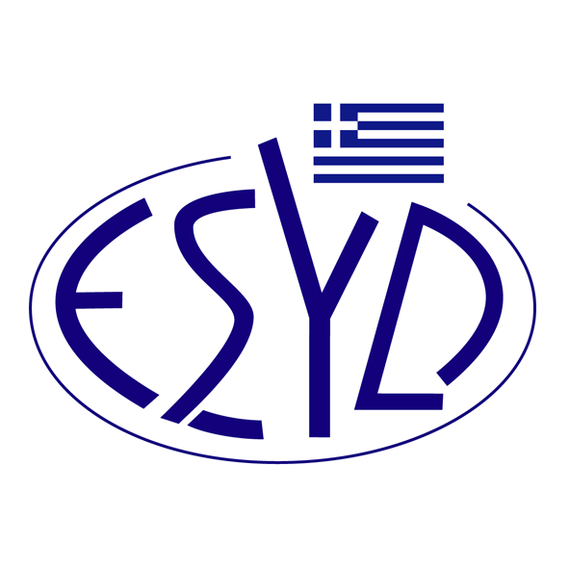

Annex F1/3 to the Certificate No.1265-2

SCOPE of ACCREDITATION

of the
Testing Laboratory

Pack-Lab L.P.

Tested materials/ products | Types of test/ Properties to be measured | Applied standards/ Techniques to be used

Chemical tests

Materials in contact with food products | - Overall migration in aqueous food simulant ethanol 10 %, 20 %, 50 %, acetic acid 3 % by total immersion. | ΕΝ 1186-3:2022
Materials in contact with food products | - Overall migration in aqueous food simulant ethanol 10 %, 20 %, 50 %, acetic acid 3 % using a cell. | ΕΝ 1186-3:2022
Materials in contact with food products | - Overall migration in aqueous food simulant ethanol 10 %, 20 %, 50 %, acetic acid 3 % by article filling. | ΕΝ 1186-3:2022
Materials in contact with food products | - Overall migration using simulant E (adsorption by poly (2,6-diphenyl-p-phenylene oxide)- Tenax). | EN 1186-13:2002
Materials in contact with food products | - Overall migration into substitutes of simulant D2 (Ethanol 95% and Iso-octane) by total immersion, cell and article filling. | ΕΝ 1186-3:2022

Mechanical tests

Flexible materials (e.g., plastic, paper) | Determination of the coefficients of friction (CoF) | ISO 8295:2004
Flexible materials (e.g., plastic, paper) | Determination of seal strength | DIN 55529:2005-09

Site of assessment: Permanent laboratory premises, Platonos 52, 56 224, Thessaloniki, Greece.
Approved Signatories: Theodoros Paraskevopoulos

This scope of Accreditation replaces the previous one dated 24.02.2023.
The Accreditation Certificate No. 1265-2, to ELOT EN ISO/IEC 17025:2017, is valid until 12.09.2025.

Athens, 16.01.2024

Christos Nestoras
CEO of ESYD

