Hellenic Accreditation System
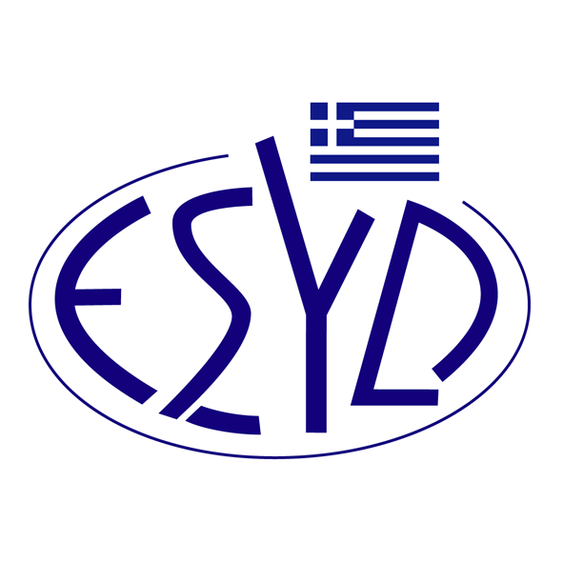

Annex Β8/5 to the Certificate No. 49-11

SCOPE of ACCREDITATION
of

TÜV AUSTRIA HELLAS Ltd.

as a Certification Body of Products / Processes
in accordance with AGRO 2 normative documents

Activity | Normative Documents
Certification of Agricultural Products / Processes | AGRO 2-1 (3rd version, 05.12.2019)  Management of Rural Environment – Integrated Management in Agricultural Production  Part 1: Specification
Certification of Agricultural Products / Processes | AGRO 2-2 (3rd version, 05.12.2019)  Management of Rural Environment – Integrated Management in Agricultural Production  Part 2: Requirements for the Application in Crop Production

Address of the Body: 429, Mesogion Avenue, Agia Paraskevi, 15343, Athens, Greece
Approved signatory: Ιοannis Kallias, Iakovina Vardalachou, Charalabos Ageloudis, Maria Agapitou, Helen Stavropoulou

This Scope of Accreditation replaces the previous one dated 14.12.2022.
The Accreditation Certificate No. 49-11, according to ELOT EN ISO/IEC 17065:2012, is valid up to 27.12.2025.

Athens, 23.04.2024

Christos Nestoras
CEO of ESYD

