Hellenic Accreditation System
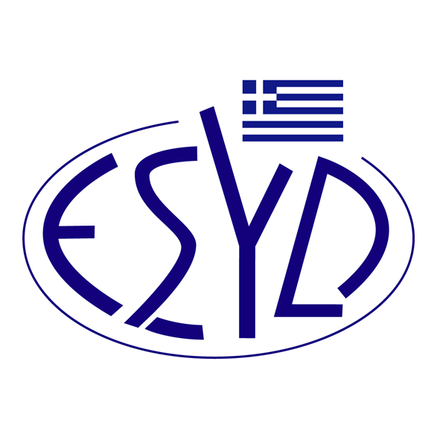

Annex Β3/13 to the Certificate No. 654-7

SCOPE of ACCREDITATION

of

QMSCERT AUDITS-INSPECTIONS-CERTIFICATIONS SA
(Q-CERT SA)

as an Organic Products Certification Body

Product/Field of Certification | Regulation/Standard
Organic products certification of the following categories*:  Α Unprocessed plants and plant products, including seeds and other plant reproductive material  Β. Livestock and unprocessed livestock products  C. Algae and unprocessed aquaculture products  D. Processed agricultural products, including aquaculture products, for use as food  Ε. Feed  G. Other products listed in Annex I to Regulation (EU) 2018/848 or not covered by the previous categories  - essential oils | - Regulation (EU) 2018/848 of the European Parliament and of the Council, as modified, completed and valid until now.  - Commission Implementing and Delegated Regulations of Regulation (EU) 2018/848, as modified, completed and valid until now.  - M.D. 2543/103240/ G.G. Β΄ 3529/09.10.2017.
* Product categories as defined in Article 35, §7 of Regulation (EU) 2018/848. Group certification is not included.

Address of the Body : 28, Vlasiou Gavrielidi street, 546 55 Thessaloniki, Greece

Approved signatories : Ε. Bakirtzi, F. Vasiliou

This Scope of Accreditation replaces the previous one, dated 14.12.2022.
The Accreditation Certificate No. 654-7, according to ELOT EN ISO/IEC 17065:2012, is valid until 12.01.2027.

Athens, 23.01.2023

Christos Nestoras
CEO of ESYD

