Hellenic Accreditation System
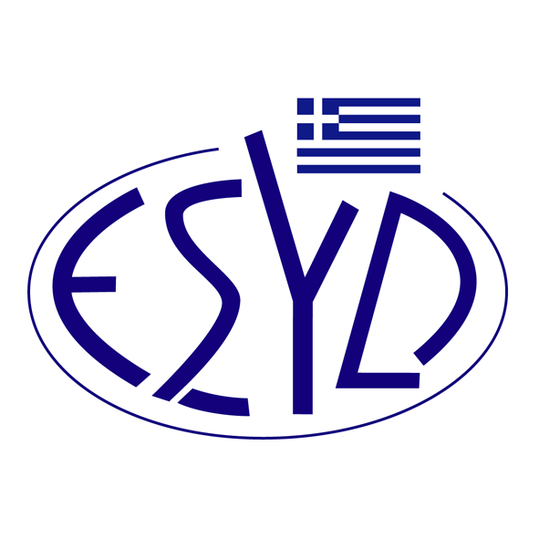

Annex F1/3 to the Certificate No.1239

SCOPE of ACCREDITATION
of the
Testing Laboratory
of
CheMa Laboratories Analytical Laboratories General Partnership

Tested Materials / Products | Types of Test / Properties to be measured | Applied Standards / Techniques to be used
Chemical testing
Honey | 1. Determination of moisture | Refractometric method, “Harmonized Methods of the International Honey Commission”, p. 10-15
Honey | 2. Determination of electrical conductivity | Potentiometric method, “Harmonized Methods of the International Honey Commission”, p. 16-18
Honey | 3. Determination of ΗΜF (hydroxymethylfurfural) | Spectrophotometric method White, “Harmonized Methods of the International Honey Commission”, p. 29-31
Honey | 4. Determination of diastase activity | Spectrophotometric method Schade, “Harmonized Methods of the International Honey Commission”, p. 35-38
Honey | 5. Determination of pH | In-house method based on “Harmonized Methods of the International Honey Commission”, p. 21-23
Honey | 6. Determination of free acidity | In-house method based on “Harmonized Methods of the International Honey Commission”, p. 21-23
Honey | 7. Determination of sugars (fructose, glucose, sucrose, maltose) | In-house method using HPLC/RI based on “Harmonized Methods of the International Honey Commission”, p. 46-48
Olive and olive pomace oils | 1. Determination of acidity | COI/T.20/Doc. No 34/Rev. 1, 2017
Olive and olive pomace oils | 2. Determination of peroxide value | COI/T.20/Doc. No 35/Rev.1, 2017
Olive and olive pomace oils | 3. Spectrophotometric investigation in the ultraviolet (K values at 268 nm and 232 nm) and the parameter ΔK | COI/T.20/Doc. No 19/Rev. 5, 2019
Potable, surface water and waste water | Determination of pH | APHA-4500-H+, 23rd ed., 2017*
Potable and surface water | 1. Determination of electrical conductivity | Method No.: WTR02  In house method based on APHA-2510Β, 23rd ed., 2017*
Potable and surface water | 2. Determination of nitrates (NO₃⁻) | Method No.: WTR03  In house method based on APHA-4500-ΝΟ₃ Β,, 23rd ed., 2017*
Potable and surface water | 3. Determination of chloride (Cl⁻) | Method No.: WTR04  Macherey Nagel test kit 91820
Potable and surface water | 4. Determination of nitrites (NO₂⁻) | Method No.: WTR05  Macherey Nagel test kit 91867
Potable and surface water | 5. Determination of ammonium (NH₄⁺) | Method No.: WTR06  Macherey Nagel test kit 91805
Food (Bakery wares, beverages, seasonings and condiments, sauces) | 1. Determination of sorbic acid and benzoic acid | In-house method using HPLC/DAD based on ISO 22855:2008.
Microscopic testing
Honey | Qualitative pollen analysis in honey | Method No.: HON04  In house method based on J. Louveaux et al., Methods of Melissopalynology, Bee World, 59:4, 139-157 (1978)
Honey | Determination of % pollen grains of thymus, citrus, castanea, helianthus, erica in honey
Honey | Qualitative and quantitative determination of starch

* American Public Health Association, American Water Works Association, Water Environment Federation, “Standard Methods for the Examination of Water and Wastewater”, 23rd Edition, 2017

Site of assessment : Permanent Laboratory premises, Xenofontos 2, Corinth,Greece
Approved signatories: A. Kampolis , F. Ravani

This Scope of Accreditation replaces the previous one dated 27.03.2024.

The Accreditation Certificate No.1239, according to ELOT EN ISO/IEC 17025:2017, is valid until 22.09.2025.

Athens, 07.02.2025

Konstantinou Evangelos Apostolos
CEO of ESYD

