Hellenic Accreditation System
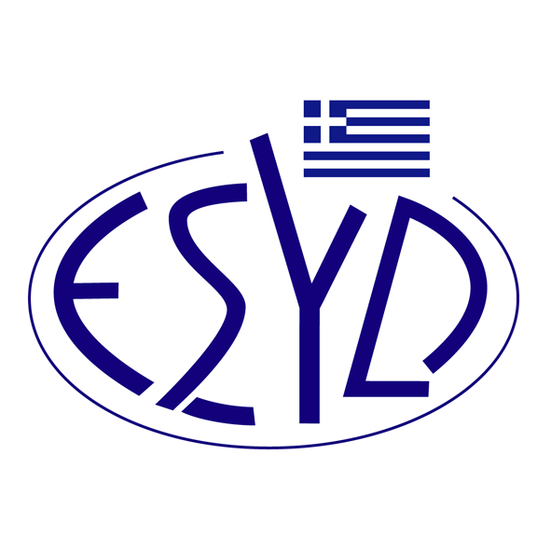
Annex Α18/14 to the Certificate No. 236-9

SCOPE of ACCREDITATION
of

TÜV AUSTRIA HELLAS Ltd.

as an Energy Management Systems Certification Body
in accordance with ELOT EN ISO 50001:2018

Technical Area | Description
Industry – light to medium | Manufacturing facilities producing consumer intermediates or end user oriented products
Industry – heavy | Manufacturing facilities requiring high capitalization and consuming large quantities of raw materials and energy
Buildings | Facilities with standard commercial building practices
Building complexes | Facilities with operations requiring specific expertise due to the complexity of energy sources and uses
Transport | System or means for transporting people or goods/cargo
Energy supply | Energy generation (CHP, electricity, renewable) and transport (transmission and distribution)
Mining | Open cast, underground and fluid extraction of raw materials and transport

Address of the Body : 429, Mesogion Avenue, Agia Paraskevi, 153 43, Greece
Approved Signatory : Ioannis Kallias, Charalabos Ageloudis, Rashid Mehr, Maria Agapitou, Ana Vega, Yankı Ünal

Accreditation granted according to ELOT ISO 50003:2021.
This Scope of Accreditation replaces the previous one dated 22.12.2023.
The Accreditation Certificate Νο.236-9, according to ELOT EN ISO/IEC 17021-1:2015, is valid until 27.12.2029.

Athens, 16.12.2024

Konstantinos Kourtalis
Chairman of ESYD

