Hellenic Accreditation System
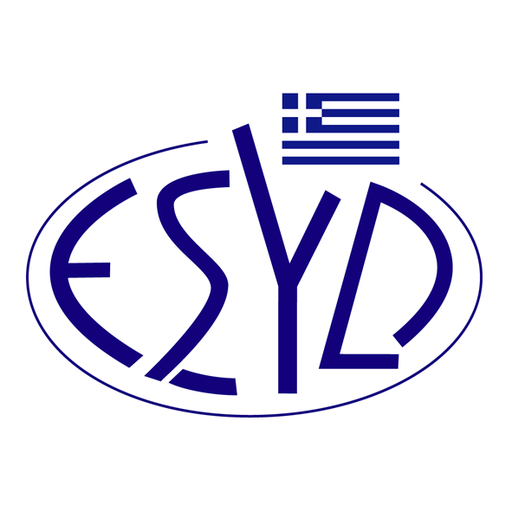

Annex Β7/4 to the Certificate No. 654-7

SCOPE of ACCREDITATION
of

QMSCERT AUDITS- INSPECTIONS- CERTIFICATIONS SA
(Q-CERT SA)

as a Products Certification Body
according to QS. Quality Scheme for Food

Product | Stage | Regulation/Standard
Fruit, Vegetables, Potatoes | Wholesale | QS General Regulations (version 01.01.2022)  QS Wholesale Fruit, Vegetables, Potatoes (version 01.01.2022)  QS Logistics Fruit, Vegetables, Potatoes (version 01.01.2022)

Address of the Body: 28, Vlasiou Gavrielidi str., 546 55 Thessaloniki, Greece

Approved signatory: E. Bakirtzi, L. Karanikas

This Scope of Accreditation replaces the previous one dated 14.12.2022.
The Accreditation Certificate No. 654-7, according to ELOT EN ISO/IEC 17065:2012, is valid until 12.01.2027.

Athens, 23.01.2023

Christos Nestoras
CEO of ESYD

