Hellenic Accreditation System
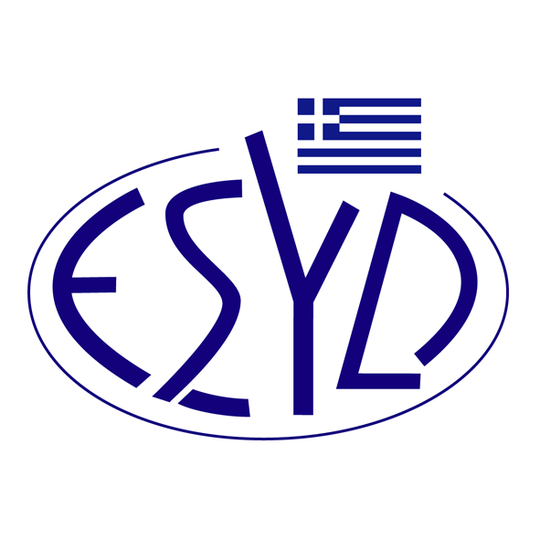
Annex Α1/8 to the Certificate No. 1099-4

SCOPE of ACCREDITATION
of

RIGCERΤ IKE
(RIGCERT)

as a Certification Body of Quality Management Systems,
in accordance with ELOT EN ISO 9001:2015

ΕΑ/IAF Code⁽¹⁾ | Full or Limited Scope | Accredited Activity ⁽²⁾
1 | Limited | Mixed farming. Support activities to agriculture and post-harvest crop activities. Hunting, trapping and related service activities. Forestry and Logging. Fishing and aquaculture.
2.5 | Limited | Other mining and quarrying
3 | Limited | Processing and preserving of fruit and vegetables. Manufacture of vegetable and animal oils and fats. Manufacture of dairy products. Manufacture of grain mill products, starches and starch products. Manufacture of bakery and farinaceous products. Manufacture of other food products. Manufacture of prepared animal feeds.
6 | Full | Manufacture of wood and wood products.
7 | Full | Manufacture of pulp, paper and paper products.
8 | Full | Publishing.
9 | Full | Printing.
15 | Full | Manufacture of non-metallic mineral products.
16 | Full | Manufacture of concrete, cement, lime, plaster etc.
17 | Limited | Manufacture of fabricated metal products, except machinery and equipment, steam generators, weapons and ammunition. Repair of fabricated metal products.
18 | Limited | Manufacture of machinery and equipment. Manufacture of military fighting vehicles. Repair of machinery. Installation of industrial machinery and equipment.
19 | Limited | Manufacture of computer, electronic and optical products except irradiation, electromedical and electrotherapeutic equipment, optical instruments and photographic equipment. Manufacture of electrical equipment except wiring and wiring devices. Repair of electronic and optical equipment. Repair of electrical equipment. Repair of computers and communication equipment.
23 | Full | Other manufacturing except EA/IAF Codes 4, 5, 6, 7, 14, 15, 17, 18, 19, 20, 21, 22.
28 | Full | Construction of buildings and civil engineering works.
29 | Limited | Wholesale and retail trade and repair of motor vehicles and motorcycles.  Wholesale trade and retail trade, except of motor vehicles and motorcycles. Repair of personal and household goods.
30 | Full | Hotels and restaurants.
31 | Limited | Transport, storage and communication except space transport.
32 | Full | Financial intermediation. Real estate activities. Renting.
33 | Full | Information technology.
34 | Full | Architectural and engineering activities. Technical consultancy. Research and development.
35 | Full | Other services, except trade, hotels, restaurants, transport, financial intermediation, real estate, information technology, education, health and social work.
36 | Full | Public administration
37 | Full | Education
38 | Limited | Medical and dental practice activities. Other human health activities. Hospital activities.
39 | Full | Other services, except education, health, and social work.
⁽¹⁾ ΕA/IAF Code according to IAF ID 1:2020 document.
⁽²⁾ To be filled, according to the description of “Subsections of Accreditation (02/00/20-07-2016)”, in case of limited accreditation, not covering the full scope of the respective EA/IAF Code.

Address of the Body: 4 Leontos Sofou str., 505, Thessaloniki, Greece
13 Scarlatescu street, sector 1, 011158, Bucharest, Romania
Approved signatories: C. Lupa
This Scope of Accreditation replaces the previous one, dated 30.08.2021.
The Accreditation Certificate Νο. 1099-4, according to ELOT EN ISO/IEC 17021-1:2015 is valid until 09.06.2025.

Athens, 02.12.2021
Konstantinos Kourtalis
Chairman of ESYD

