Hellenic Accreditation System
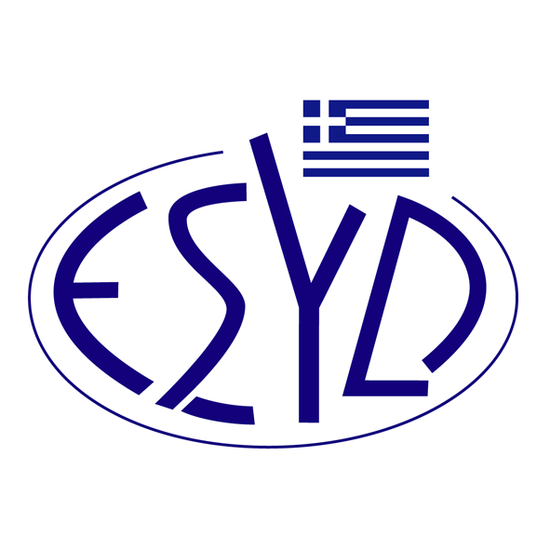
Annex Α2/10 to the Certificate No. 546-10

SCOPE OF ACCREDITATION
of

BQC PRIVATE COMPANY
(BQC)

as a Certification Body of Occupational Health and Safety Systems
in accordance to ELOT ISO 45001:2018 Standard

EA/IAF Code⁽¹⁾ | Risk Category ⁽²⁾ | Activity
3 | Medium | Manufacture of food products (except Slaughterhouses), beverages and tobacco.
5 | Medium | Manufacture of leather and leather products (except tanning of leather).
13 | High | Manufacture of basic pharmaceutical products
14 | Medium | Manufacture of rubber and plastic products.
17 | Medium | Manufacture of fabricated metal products, except metal structures, containers of metal, central heating radiators and boilers.
18 | Medium | Manufacture of machinery and equipment.
19 | Medium | Manufacture of electrical and optical equipment, except heavy metal accumulators, irradiation, electromedical and electrotherapeutic equipment.
20 | High | Shipbuilding and repairing of ships.
23 | Medium | Other manufacturing except ΙΑF/EA Codes 4, 5, 6, 7, 14, 15, 17, 18, 19, 20, 21, 22.
24 | Medium | Non-hazardous materials recovery.
28 | High | Construction of buildings and civil engineering works.
EA/IAF Code⁽¹⁾ | Risk Category ⁽²⁾ | Activity
29 | Medium | Repair of motor vehicles and motorcycles. Retail sale of automotive fuel in specialised stores. Repair of personal and household goods.
29 | Low | Wholesale and retail trade. Personal and household goods.
30 | Low | Restaurants and camping grounds.
31 | Medium | Transport or storage of non-hazardous materials. Warehousing and support activities for transportation of non-hazardous materials.
31 | Medium | Transport of passengers.
31 | Low | Telecommunications, postal and courier activities.
32 | Low | Financial intermediation. Real estate activities. Renting.
33 | Low | Information technology.
34 | Medium | Τechnical testing and analysis. Research and experimental development on social sciences and humanities. Other professional, scientific and technical activities.
34 | Low | Architectural and engineering activities.
35 | Medium | Security and investigation activities.
35 | Medium | Cleaning activities.
35 | Low | Other services, except trade, hotels, restaurants, transport, financial intermediation, real estate, information technology, education, health, and social work.
37 | Medium | Sports and recreation education. Driving school activities.
37 | Low | Higher, technical and vocational secondary education without laboratories. Pre-primary education. Primary education. General secondary education. Higher non-technical education. Cultural education. Other education except lifeguard education and diving education. Educational support activities.
39 | High | Sewerage. Collection of hazardous waste. Waste treatment and disposal. Remediation activities and other waste management services.
39 | Medium | Collection and disposal of non-hazardous waste.
39 | Low | Other social services except education, health social work services, collecting, transporting, processing and disposal of sewage.
⁽¹⁾ ΕA/IAF Code according to IAF ID 1:2020.
⁽²⁾ Risk Category according to ESYD H&S Guidance_2020.

Address of the Body: 54, Ag. Dimitriou Avenue, 17 341, Agios Dimitrios, Athens.
Approved signatory: Νiki Panopoulou.

This Scope of Accreditation replaces the previous one dated 22.08.2022.
The Accreditation Certificate Νο. 546-10, according to ELOT EN ISO/IEC 17021-1:2015, is valid until 14.05.2025.

Athens, 27.09.2023

Christos Nestoras
CEO of ESYD

