Hellenic Accreditation System
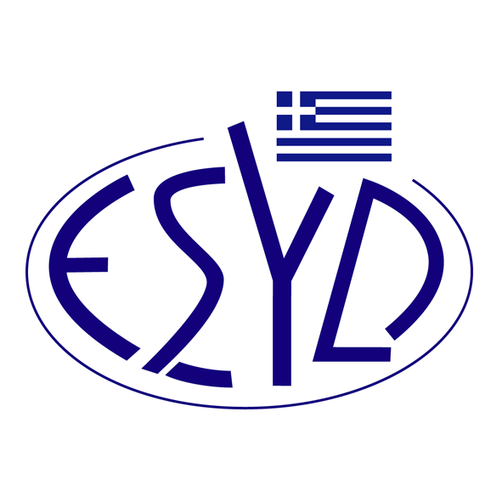
Annex Α13/10 to the Certificate No. 546-10

SCOPE of ACCREDITATION
of

BQC PRIVATE COMPANY
(BQC)

as an Environmental Management Systems Certification Body
in accordance with ELOT EN ISO 14001:2015

NACE Code⁽¹⁾ | Activity
10.3 | Processing and preserving of fruit and vegetables
10.7 | Manufacture of bakery and farinaceous products
10.8 | Manufacture of other food products
15.12 | Manufacture of luggage, handbags and the like, saddlery and harness
15.20 | Manufacture of footwear
16 | Manufacture of wood and of products of wood and cork, except furniture; manufacture of articles of straw and plaiting materials.
21.2 | Manufacture of pharmaceutical preparations.
22 | Manufacture of rubber and plastic products.
23 | Manufacture of other non-metallic mineral products
25 | Manufacture of fabricated metal products, except machinery and equipment.
26 | Manufacture of computer, electronic and optical products.
27 | Manufacture of electrical equipment.
28 | Manufacture of machinery and equipment n.e.c.
30.1 | Building of ships and boats
33.15 | Repair and maintenance of ships and boats
31 | Manufacture of furniture.
32.1 | Manufacture of jewellery, bijouterie and related articles.
33.11 | Repair of fabricated metal products.
33.12 | Repair of machinery.
33.13 | Repair of electronic and optical equipment.
33.14 | Repair of electrical equipment.
33.2 | Installation of industrial machinery and equipment.
37 | Sewerage.
38.1 | Waste collection.
38.21 | Treatment and disposal of non-hazardous waste.
38.3 | Materials recovery.
41 | Construction of buildings.
42 | Civil engineering.
43 | Specialised construction activities.
45.2 | Maintenance and repair of motor vehicles.
45.3 | Sale of motor vehicle parts and accessories.
45.4 | Sale, maintenance and repair of motorcycles and related parts and accessories.
46 | Wholesale trade, except of motor vehicles and motorcycles.
47 | Retail trade, except of motor vehicles and motorcycles.
49 | Land transport and transport via pipelines.
52 | Warehousing and support activities for transportation.
55 | Accommodation.
56 | Food and beverage service activities.
62 | Computer programming, consultancy and related activities.
68 | Real estate activities.
69 | Legal and accounting activities.
70 | Activities of head offices; management consultancy activities.
71 | Architectural and engineering activities; technical testing and analysis.
72 | Scientific research and development.
74 | Other professional, scientific and technical activities.
77 | Rental and leasing activities.
78 | Employment activities.
79 | Travel agency, tour operator reservation service and related activities.
80 | Security and investigation activities.
81 | Services to buildings and landscape activities.
82 | Office administrative, office support and other business support activities.
84 | Public administration and defence; compulsory social security.
85 | Education.
90 | Creative, arts and entertainment activities.
93 | Sports activities and amusement and recreation activities.
95 | Repair of computers and personal and household goods.
96 | Other personal service activities.
⁽¹⁾ NACE Code (Statistical Classification of Economic Activities in the European Community) in accordance with the Regulation 1893/2006/EC of the European Parliament and of the Council.

Address of the Body: 54, Ag. Dimitriou Avenue, 17 341, Agios Dimitrios, Athens.
Approved signatory: Νiki Panopoulou.

This Scope of Accreditation replaces the previous one dated 22.08.2022.
The Accreditation Certificate Νο. 546-10, according to ELOT EN ISO/IEC 17021-1:2015, is valid until 14.05.2025.

Athens 27.09.2023
Christos Nestoras
CEO of ESYD

