Hellenic Accreditation System
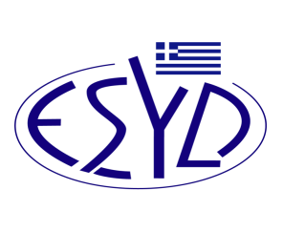
Annex C3/7 to the Certificate No. 50-10

SCOPE of ACCREDITATION
of

TÜV AUSTRIA HELLAS Ltd.
as a Type A Inspection Body
for the inspection of special equipment of vehicles for the carriage of perishable foodstuffs according to the ATP Agreement

Field of Inspection | Type of Inspection | Normative Regulations / Standards /  In house procedures
Vehicles for the international carriage of perishable foodstuffs (ATP). | Periodic inspection according to § 5 and § 6 of Appendix 2 of Annex 1 of ATP Agreement. | - J.M.D. 57687/5114 (G.G. 70/Β/12)  - J.M.D. 32031/3643 (G.G. 2499/Β/14)  - J.M.D. 50786/3319 (G.G. 2418/Β/14)

Address of the Body: 429 Mesogion Ave., 15343 Ag. Paraskevi, Athens, Greece
Approved Signatory: Ioannis Kallias, Christos Nichorlis

This Scope of Accreditation replaces the previous one dated 27.10.2022.
The Accreditation Certificate No. 50-10, according to ELOT EN ISO/IEC 17020:2012, is valid up to 27.12.2025.

Athens, 23.04.2024

Christos Nestoras
CEO of ESYD

