Hellenic Accreditation System
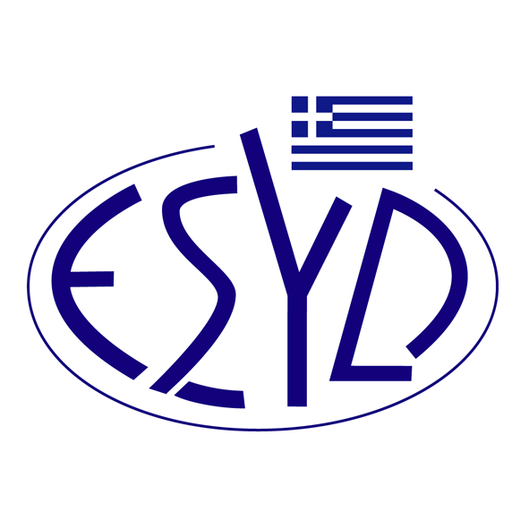
Annex B5/7 to the Certificate No. 1032-4

SCOPE of ACCREDITATION
of

BQC PRIVATE COMPANY
(BQC)

as a Products Certification Body
in the voluntary sector and/or
according to the National Legislative Regulations

Field of certification | Type of Certification | Normative Regulations / Standards /  In-House Procedures
Hotels | Technical report | M.D. 216 (G.G. 10/B/09.01.2015)  M.D. 19102 (G.G. 3387/B/20.10.2016)  M.D. 21654 (G.G. 4242/B/05.12.2017)  M.D. 4418 (G.G. 972/B/21.03.2019)  M.D. 7254 (G.G. 1596/B/10.05.2017)  as modified, completed and valid until now.

Address of the Body: 54 Agiou Dimitriou Avenue, 173 41 Agios Dimitrios, Athens, Greece.
Approved signatory: Niki Panopoulou

This Scope of Accreditation replaces the previous one, dated 27.09.2023.
The Accreditation Certificate Νο. 1032-4, according to ELOT EN ISO/IEC 17065:2012, is valid until 14.05.2029.

Athens, 15.03.2024

Christos Nestoras
CEO of ESYD

