Hellenic Accreditation System
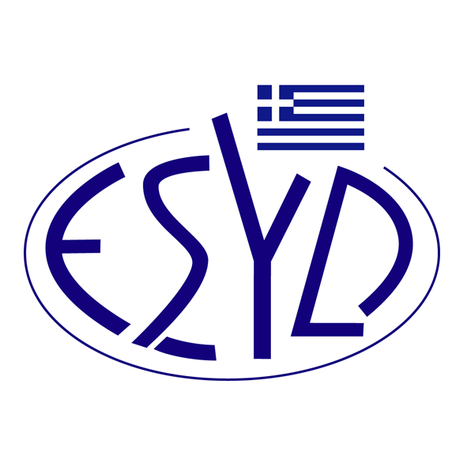

Annex V1/12 to the Certificate No. 876-5

SCOPE OF ACCREDITATION

of

TÜV AUSTRIA HELLAS Ltd.

as a Validation and Verification Body

Cluster of Activities | Activity

(in accordance with Annex I of Implementing Regulation (EU) 2018/2067)
1a | Combustion of fuels in installations, where only commercial standard fuels as defined in implementing regulation (EU) 2018/2066 are used, or where natural gas is used in category A or B installations.
1b | Combustion of fuels in installations, without restrictions
2 | Refining of mineral oil
3 | — Production of coke  — Metal ore (including sulphide ore) roasting or sintering, including pelletisation  — Production of pig iron or steel (primary or secondary fusion) including continuous casting
4 | — Production or processing of ferrous metals (including ferro-alloys)  — Production of secondary aluminium  — Production or processing of non-ferrous metals, including production of alloys
5 | —Production of primary aluminium (CO₂ and PFC emissions)
6 | — Production of cement clinker  — Production of lime or calcination of dolomite or magnesite  — Manufacture of glass including glass fibre  — Manufacture of ceramic products by firing  — Manufacture of mineral wool insulation material  — Drying or calcination of gypsum or production of plaster boards and other gypsum products
7 | — Production of pulp from timber or other fibrous materials  — Production of paper or cardboard
8 | — Production of carbon black  — Production of ammonia  — Production of bulk organic chemicals by cracking, reforming, partial or full oxidation or by similar processes  — Production of hydrogen (H₂) and synthesis gas by reforming or partial oxidation  — Production of soda ash (Na₂CO₃) and sodium bicarbonate (NaHCO₃)
12 | Aviation activities (emissions and tonne-kilometre data)
98 | Other activities pursuant to Article 10a of Directive 2003/87/EC.  Commission Delegated Regulation (EU) 2019/331

Activity | Standard
Verification of reporting of GHG emissions and removals | Specification with guidance at the organization level for quantification and reporting of greenhouse gas emissions and removals according to ELOT EN ISO 14064-1:2019
Validation and Verification of GHG emissions reductions and removal projects | Specifications with guidance at the project level for quantification, monitoring and reporting of greenhouse gas emission reductions or removal enhancements according to ELOT ΕΝ ISO 14064-2:2019

Activity | Standard
Verification of CO₂ emissions from international aviation | Standards and Recommended Practices SARPs, Annex 16 - Environmental Protection, Volume IV – Carbon Offsetting and Reduction Scheme for International Aviation (CORSIA) (First Edition, October 2018)  Environmental Technical Manual, Volume IV – Procedures for demonstrating compliance with the Carbon Offsetting and Reduction Scheme for International Aviation (CORSIA) (Second Edition, February 2019)

Address of the Body: 429, Mesogion avenue, Agia Paraskevi, GR-153 43 Athens, Greece.
Approved Signatories: I. Kallias, I. Vardalachou, C. Ageloudis, M. Agapitou, Yanki Ünal.

Accreditation is granted according to ELOT EN ISO 14065:2022.

This scope of accreditation replaces the previous one dated 04.08.2023.
The Accreditation Certificate No. 876-5, according to ELOT EN ISO/IEC 17029:2019, is valid until 27.12.2025.

Athens, 15.01.2024

Christos Nestoras
CEO of ESYD

