Hellenic Accreditation System
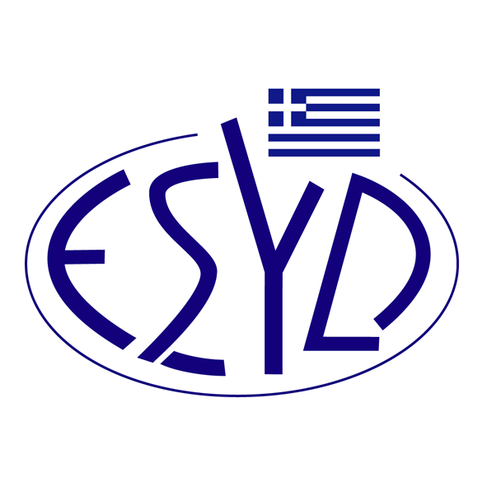

Annex Α13/24 to the Certificate No. 236-9

SCOPE of ACCREDITATION
of

TÜV AUSTRIA HELLAS Ltd.

as an Environmental Management Systems Certification Body
in accordance with ELOT EN ISO 14001:2015

IAF Code(1) | Full (1)or Limited Scope(1) | Accredited Activity ⁽²⁾
1 | Limited | Fishing and aquaculture
2 | Full | Mining of coal and lignite. Extraction of crude petroleum and natural gas. Mining of metal ores. Other mining and quarrying. Mining support service activities.
3 | Limited | Manufacture of food products. Manufacture of beverages.
6 | Full | Manufacture of wood and of products of wood and cork, except furniture; manufacture of articles of straw and plaiting materials
7 | Full | Manufacture of paper and paper products.
8 | Limited | Publishing of books, periodicals and other publishing activities
9 | Limited | Printing and service activities related to printing.
10 | Full | Manufacture of coke and refined petroleum products
12 | Limited | Manufacture of basic chemicals, fertilisers and nitrogen compounds, plastics and synthetic rubber in primary forms. Manufacture of pesticides and other agrochemical products. Manufacture of paints, varnishes and similar coatings, printing ink and mastics. Manufacture of soap and detergents, cleaning and polishing preparations, perfumes and toilet preparations. Manufacture of other chemical products.
13 | Full | Manufacture of basic pharmaceutical products and pharmaceutical preparations
14 | Full | Manufacture of rubber and plastic products
15 | Limited | Manufacture of glass and glass products. Manufacture of other porcelain and ceramic products. Cutting, shaping and finishing of stone.
16 | Full | Manufacture of cement, lime and plaster. Manufacture of articles of concrete, cement and plaster
17 | Full | Manufacture of basic metals (except of Processing of nuclear fuel). Manufacture of structural metal products. Manufacture of tanks, reservoirs and containers of metal. Manufacture of steam generators, except central heating hot water boilers. Forging, pressing, stamping and roll-forming of metal. Powder metallurgy. Treatment and coating of metals. Machining. Manufacture of cutlery, tools and general hardware. Manufacture of other fabricated metal products. Repair of fabricated metal products.
18 | Limited | Manufacture of machinery and equipment n.e.c. Repair of machinery. Installation of industrial machineryand equipment
19 | Limited | Manufacture of electrical equipment. Repair of electronic and optical equipment. Repair of electrical equipment. Repair of computers and communication equipment.
22 | Full | Manufacture of motor vehicles. Manufacture of bodies (coachwork) for motor vehicles; manufacture of  trailers and semi-trailers. Manufacture of parts and accessories for motor vehicles. Manufacture of railway locomotives and rolling stock. Manufacture of transport equipment n.e.c.
23 | Limited | Manufacture of furniture. Repair of other equipment.
24 | Full | Materials recovery.
25 | Full | Electric power generation, transmission and distribution
26 | Full | Manufacture of gas; distribution of gaseous fuels through mains.
28 | Full | Construction of buildings. Civil engineering. Specialised construction activities.
29 | Limited | Sale of motor vehicles. Maintenance and repair of motor vehicles. Sale of motor vehicle parts and accessories. Sale, maintenance and repair of motorcycles and related parts and accessories. Wholesale trade, except of motor vehicles and motorcycles. Retail trade, except of motor vehicles and motorcycles.
30 | Full | Accommodation. Food and beverage service activities.
31 | Limited | Other passenger land transport. Freight transport by road and removal services. Transport via pipeline. Air transport. Warehousing and support activities for transportation. Postal and courier activities. Telecommunications.
32 | Limited | Financial service activities, except insurance and pension funding. Activities auxiliary to insurance and pension funding. Real Estate activities.
33 | Full | Software publishing. Computer programming, consultancy and related activities. Data processing, hosting and related activities. Web portals.
34 | Limited | Architectural and engineering activities and related technical consultancy. Technical testing and analysis. Scientific research and development. On the road customer services.
35 | Limited | Activities of head offices; management consultancy activities. Advertising and market research. Photographic activities. Translation and interpretation activities. Employment activities. Security and investigation activities. Services to buildings and landscape activities. Photocopying, document preparation and other specialised office support activities. Activities of call centers. Business support service activities n.e.c. Packaging activities.
36 | Full | Public administration and defence; compulsory social security
37 | Full | Education.
38 | Limited | Hospital activities. Medical and dental practice activities. Other human health activities. Other residential care activities.
39 | Limited | Waste collection. Waste treatment and disposal. Remediation activities and other waste management services. Programming and broadcasting activities. Travel agency, tour operator and other reservation service and related activities. Creative, arts and entertainment activities. Sports activities and amusement and recreation activities.

- Κωδικός ΕA/IAF σύμφωνα με το έγγραφο IAF ID 1:2023.
- Eurostat NACE Rev.2

Address of the Body : 429, Mesogion av., Aghia Paraskevi, 153 43, Greece.
Approved signatories : Ioannis Kallias, Charalabos Ageloudis, Rashid Mehr, Maria Agapitou, Celebi Burcu, Ana Vega, Yankı Ünal

This Scope of Accreditation replaces the previous one dated 17.01.2024.
The Accreditation Certificate Νο. 236-9, according to ELOT EN ISO/IEC 17021-1:2015, is valid until 27.12.2029.

Athens, 16.12.2024

Konstantinos Kourtalis
Chairman of ESYD

