Hellenic Accreditation System
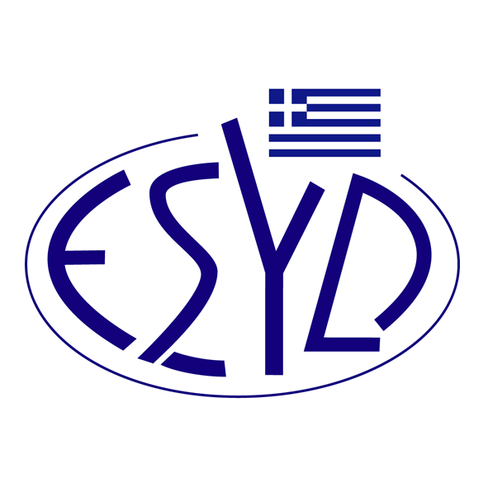

Annex A8/17 to the Certificate No. 110-10

SCOPE of ACCREDITATION

of

QMSCERT AUDITS-INSPECTIONS-CERTIFICATIONS SA
(Q-CERT SA)

as a Certification Body of Quality Assurance Systems
in accordance with E.C. Directives

Scope of certification | Type of conformity assessment | Nominative Regulations / Modules / Annexes
Safety components for lifts | - Conformity based on full quality assurance Annex VII, Module H | - Directive 2014/33/EU,  - J.M.D. 39507/167/F.9.2/2016 (G.G. 1047/Β/2016)

Address of the Body : 28, Vlasiou Gavriilidi street, 546 55, Thessaloniki, Greece

Approved signatories : L. Karanikas, E. Bakirtzi

This Scope of Accreditation replaces the previous one dated 13.04.2023.
The Accreditation Certificate Νο.110-10, according to ELOT EN ISO/IEC 17021-1:2015, is extended until 12.07.2025.

Athens, 18.12.2024

Konstantinos Kourtalis
Chairman of ESYD

