Hellenic Accreditation System
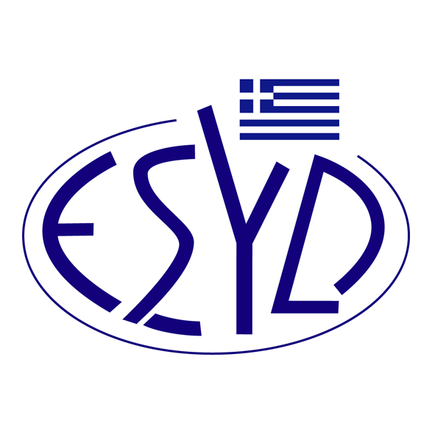

Annex Α7/20 to the Certificate No. 236-9

SCOPE OF ACCREDITATION
of

TÜV AUSTRIA HELLAS Ltd.

as a Certification Body
of Food Safety Management Systems
according to ELOT EN ISO 22000:2018 Standard

Category codes | Activity
A | Farming or handling of animals
BIII | Pre-process handling of plant products
C | Food, ingredient and pet food processing
D | Feed and animal food processing
E | Catering/ food service
F | Trading, retail and e-commerce
G | Transport and storage services
H | Services
I | Production of packaging material
K | Chemical and bio-chemical
Address of the Body: 429, Mesogion Avenue, Agia Paraskevi, 15343, Athens, Greece
Approved signatory: Yiannis Kallias, Charalabos Ageloudis, Rashid Mehr, Maria Agapitou, Ana Vega, Yanki Unal

This Scope of Accreditation replaces the previous one, dated 19.11.2024.
Accreditation granted according to ISO 22003-1:2022.
The Accreditation Certificate Νο. 236-9, according to ELOT EN ISO/IEC 17021-1:2015, is valid until 27.12.2029.

Athens, 16.12.2024

Konstantinos Kourtalis
Chairman of ESYD

