Hellenic Accreditation System
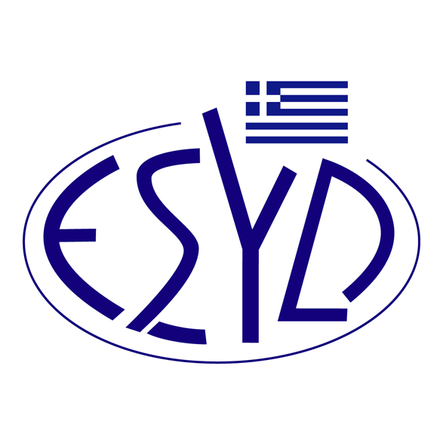
Annex Α17/18 to the Certificate No. 236-9

SCOPE OF ACCREDITATION
of

TÜV AUSTRIA HELLAS Ltd.

as a Certification Body
of Food Safety Management Systems
according to FSSC 22000 version 6
(ELOT ΕΝ ISO 22000:2018, Additional Requirements of the Certification Scheme, Normative Documents applicable per Category)
Category codes | Activity | Normative Documents
ΒΙΙΙ | Pre-process handling of plant products | ISO/TS 22002-1:2009
C | Food, ingredient and pet food processing | ISO/TS 22002-1:2009
E | Catering/ food service | ISO/TS 22002-2:2013
FI | Retail/Wholeshale | BSI/PAS 221:2013
I | Production of packaging material | ISO/TS 22002-4:2013
K | Chemical and bio-chemical | ISO/TS 22002-1:2009
Address of the Body: 429, Mesogion Avenue, Agia Paraskevi, 15343, Athens, Greece
Approved signatory: Yiannis Kallias, Charalabos Ageloudis, Maria Agapitou, Rasid Mehr, Yanki Unal, Ana Vega.

This Scope of Accreditation replaces the previous one, dated 28.03.2024.
Accreditation granted according to ISO 22003-1:2022.
The Accreditation Certificate Νο.236-9, according to ELOT EN ISO/IEC 17021-1:2015, is valid until 27.12.2029.

Athens, 16.12.2024
Konstantinos Kourtalis
Chairman of ESYD

