Hellenic Accreditation System

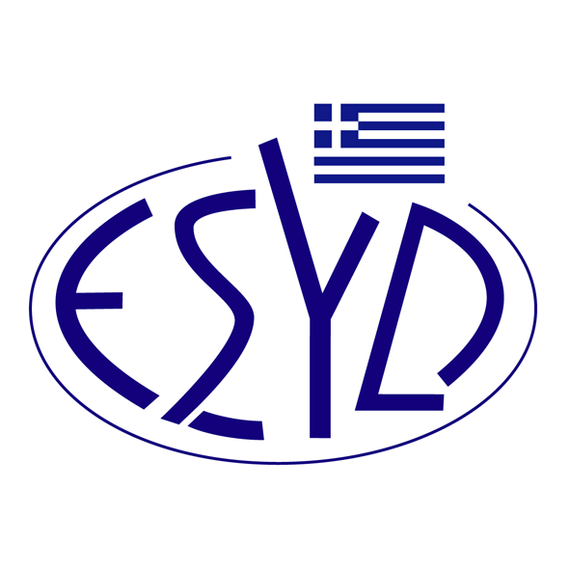

Annex A4/13 to the Certificate No. 110-10

SCOPE OF ACCREDITATION

of

QMSCERT AUDITS-INSPECTIONS-CERTIFICATIONS SA
(Q-CERT SA)

as a Certification Body of Information Security Management Systems
in accordance with ELOT ΕΝ ISO/IEC 27001:2023

Activity | Standard
Information Security Management Systems Certification | ELOT ΕΝ ISO/IEC 27001:2023  (ISO/IEC 27001:2022)
Information Security Management Systems Certification  Privacy Information Management | ΕLΟΤ EN ISO/IEC 27001:2023  EΛOT ISO/IEC 27001:2013  ΕLΟΤ ΕΝ ISO/IEC 27701:2021  (ISO/IEC 27701:2019)

Address of the Body : 28, Vlasiou Gavrielidi street, 546 55 Thessaloniki, Greece
Approved signatories : L. Karanikas, E. Bakirtzi

This Annex is granted according to ISO/IEC 27006:2015/Amd1:2020.

This Scope of Accreditation replaces the previous one dated 12.01.2024.
The Accreditation Certificate Νο.110-10, according to ELOT EN ISO/IEC 17021-1:2015, is extended until 12.07.2025.

Athens, 18.12.2024

Konstantinos Kourtalis
Chairman of ESYD

